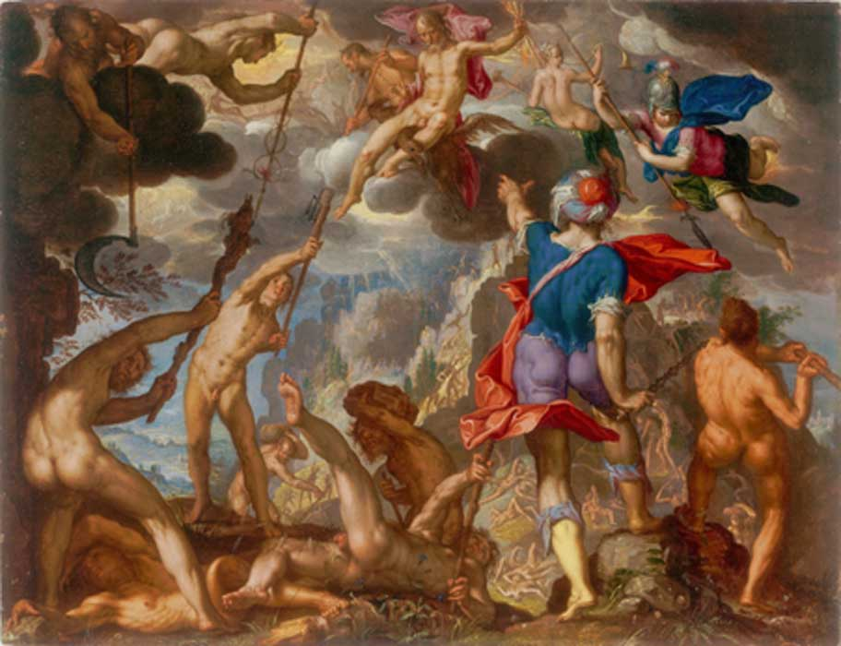=

**Geography**

In year 4, we will be expanding our ‘place knowledge’ with a focus on Europe (tying into learning about Greeks and Greek Mythology in History and English) and comparing other locations to the UK, England and Bearpark.

**Geographical Skills:**

Children will describe and understand key aspects of:

* Understanding geographical similarities and differences through the study of human and physical geography of a region of the UK, a region of a European country and a region within Southern or Northern America.

**Maths**

We will continue to build on our knowledge and understanding of times tables from 1 to 12 in preparation for the statutory year 4 times table test in June 2020. Our units we will cover this term are:

* Fractions
* Decimals
* Percentages

We will continue to revisit all we have learnt in the Autumn term (addition, subtraction, multiplication, division and place value) and apply this knowledge to the three elements above.

Class 4   
Spring Term

**RE**

Building on our knowledge and Understanding of the Bible and why it is special to Christians, year four will look at what Christians believe about Jesus and how that influences their lives. We will build on this knowledge by comparing it to another religion – Judaism.

**Skills:**

* Ask and answer questions
* Critical thinking
* Personal reflection
* Reflect and respond

**Science**

The ‘Sound’ unit will allow us to explore and identify the way sound is made through vibrations in a range of different musical instruments from around the world. We will look at how sound can be controlled in terms of pitch and volume. Children will be able to identify how sounds are made and recognise that the vibrations sound is made from can travel through a medium to the ear in order to be heard. We will look at the patterns between volume and strength of vibrations as well as understand that sounds get fainter as the distance from the source increases.

**Scientific Skills we will gain this term:**

* Find patterns in the sounds that are made by different objects and different sized objects.
* Explore a variety of materials to see how sound can be changed.
* Investigate how sound can be insulated
* Explore pitch and volume.

# History

Our topic in History this term will lend itself to our pupils learning all the skills of being a good Historian. We will look at artefacts to build upon our skills to help us become Historians. Our focus will be on The Roman Empire and its impact on Britain as well as the Viking and Anglo-Saxon struggle for control of the United Kingdom. We will look at the legacy of Greek culture on later periods of British history and now.

**English**

We will be focusing on the stories from ‘The twelve Labours of Hercules’ from Greek Mythology the first half of Spring Term.

Reading

Listening to and discussing a wide range of texts.

Using dictionaries to check the meaning of words.

Drawing inferences, making predictions and retrieving information.

# Writing

Using prefixes and suffixes

Accurately placing the possessive apostrophe

Writing from memory

Planning, drafting, evaluating and editing our own work

Using a wider range of conjunctions

Using fronted adverbials, adverbs and prepositions

Choosing nouns and pronouns appropriately for clarity and cohesion

Using and punctuating direct speech

**Music**

What is the history of music? Can you play a musical instrument with control and expression? Can you perform in a group and as a solo? Can you improvise and compose music for a range of purposes? Do you appreciate and understand music from great composers and musicians? This will be linked heavily to our science unit of Sound.

**Computing**

Can you design, write and debug programs to accomplish specific goals? Can you explain simple algorithms? Can you use search technologies effectively? Do you understand the importance of using technology safely, respectfully and responsibly?

**Computing Skills:**

Sequencing, selecting and repeating programs

Using logical reasoning

Recognising acceptable/unacceptable behaviour

Identifying a range of ways to report concerns about content and contact

# Art, Design & Technology

Can you master different design techniques, including drawing, painting and sculpting using a range of materials? Do you know about great artists in history?

Can you select materials, textiles and ingredients according to their properties and qualities? Can you select from and use a wider range of tools and equipment to perform practical tasks for example, cutting, shaping, joining and finishing? Do you understand the principles of a healthy and varied diet?