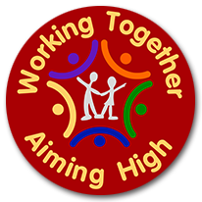

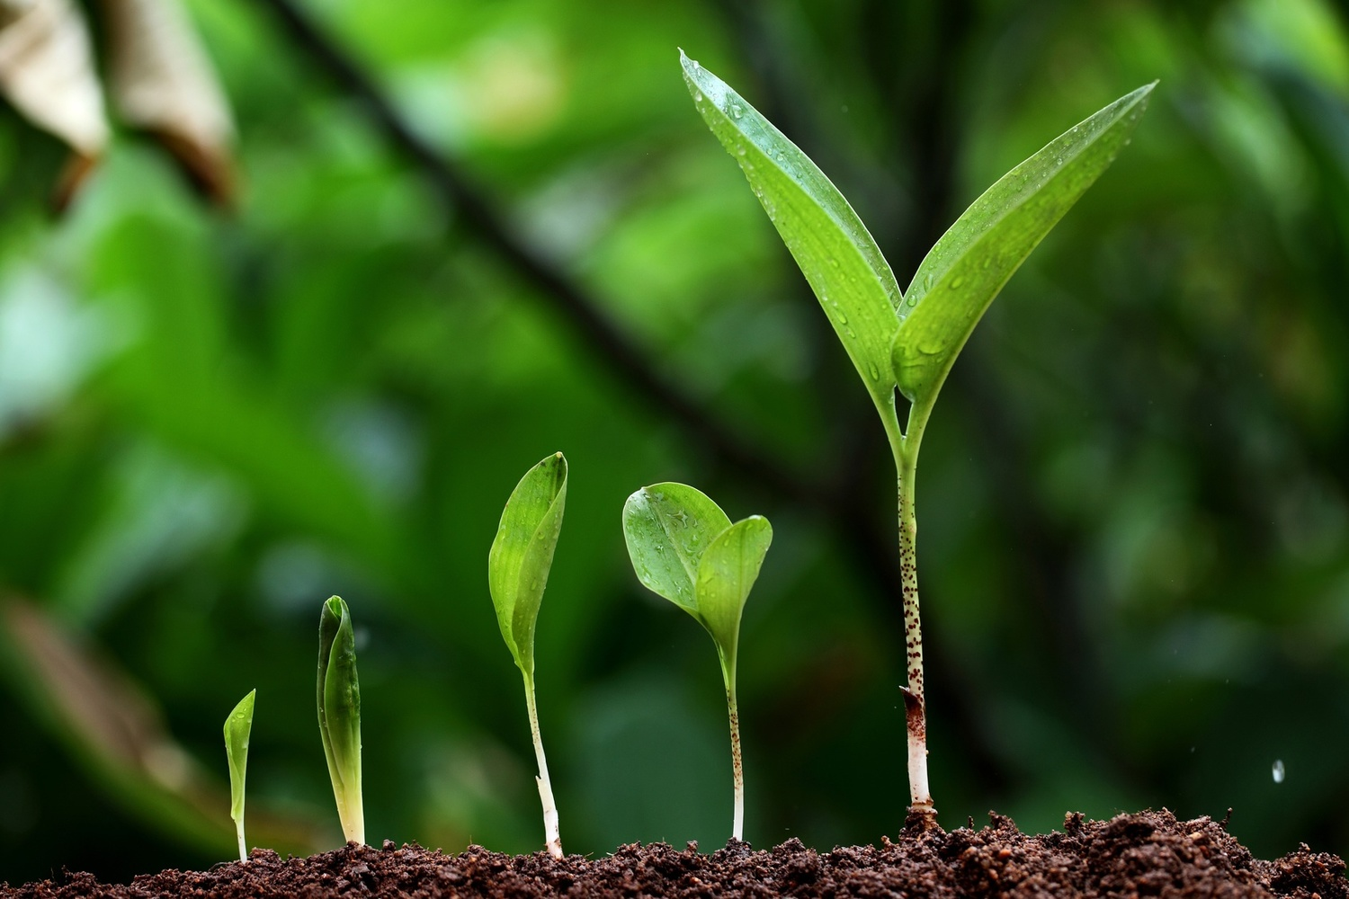

This is what a typical week looks like for Year 2 children.

|  |  |  |  |
| --- | --- | --- | --- |
| Monday | Spelling/Phonics  Maths and English | Art | Science |
| Tuesday | Spelling/Phonics  Maths and English | RE/SMSC | Fiction Express/Reading |
| Wednesday | Spelling/Phonics  Maths and English | Music  PHSE | PE |
| Thursday | Spelling/Phonics  Maths and English | History | Computing |
| Friday | Spelling/Phonics  Maths and English | Golden Time | PE |

Year 2

Bearpark Primary School

**Changes and Growth**

**Homework**

Homework will be given out every Friday and should be returned by Wednesday of the following week.

**Supporting your child’s learning**

Reading at home at least 3 times each week is essential. Using Fiction Express, TT Rock Stars and apps such as Hit the Button.

Practising their times tables and asking them division questions too. (2X, 3X, 5X and 10X)

If you have any questions or concerns, however small, please do not hesitate to speak to me. Mrs Jones

RE

English

Non-fiction texts – A range of texts linked to our topics – The Great Fire of London and Plants.

Fiction Texts – Toby and the Great Fire of London; a variety of alternative Fairy Tales, including Goldilocks and Just the One Bear and Mr Wolf’s Pancakes; The Tear Thief and The Lonely Beast.

We will be looking at the diary of Samuel Pepys.

We will be planning and writing for a range of purposes and developing our reading skills.

Maths

Daily Early Maths

Number: Multiplication and Division; Fractions

Geometry: Properties of Shape

Statistics

Measurement: length and height; mass; time.

Science

We will be exploring everyday materials and their uses. We will compare suitability of everyday materials for a variety of purposes and how these materials can change.

We will learn about plants and growth, including being able to name the main parts of a plant, describe the different stages in a plant’s life cycle, recognise common plants and explain what a plant needs for healthy growth.

History

We will be looking at The Great Fire of London. We will be using a range of sources to find out about the fire. We will also find out about the Great Fire of Bearpark School.

Art/DT

We will be developing our artistic skills – using a variety of techniques, including printing and painting. We will also be using charcoal and pencil to develop drawing and shading skills.

We will also learn about healthy eating and prepare a variety of salads.

PE

Through Dance, we will develop control, coordination, balance, poise and elevation in the basic actions of travelling, jumping, turning, gesture and stillness. We will be exploring shape, balance and travel in Gymnastics and children will be making gymnastic sequences.

Music

We will be singing and learning to play the recorder.

RE

We will be learning about the importance of belonging in Christianity and how Christians celebrate Easter.

Computing

We will be learning about staying safe online. We will be learning how to use block programming with Scratch Junior to complete a simple program. We will also be developing our ICT skills using publisher and word to create reports and posters.

**Changes and Growth**