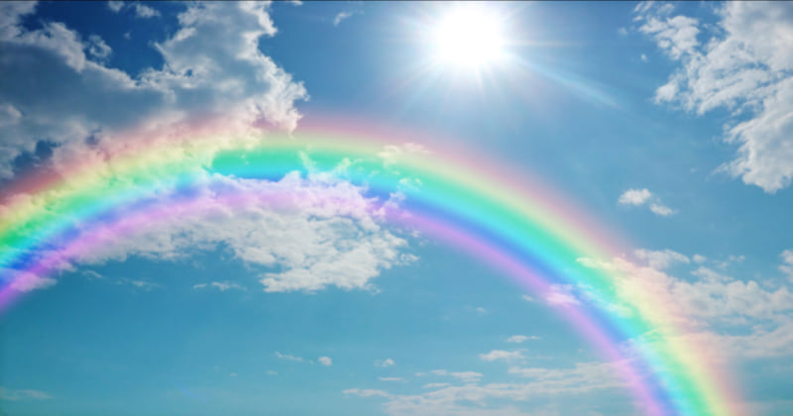

Science 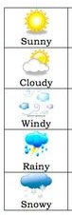

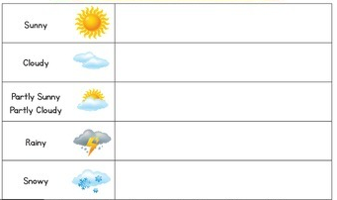Set up a daily weather chart.

What is the weather like? Can you draw the symbol? At the end of each week can you make a tally and compare?

English

Can you think of a traditional tale that you know and draw a story map or a story mountain of the plot with pictures and key words? What happens at the beginning, the build-up, the problem, the resolution and the ending? Is it a happy ending? 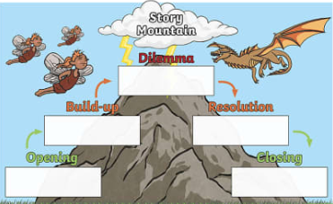

C

Maths 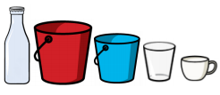 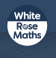

Weight and Volume.

For maths, this week we will be looking at weight and volume.

Please follow this link to White Rose Maths Home Learning:

.<https://whiterosemaths.com/homelearning/year-1/>

There is a lesson for each week day which includes a short video and an activity sheet which are like the ones we often use in class.

Activity ideas:

While you are helping with the dishes or in the bath, could you fill up different amounts of water in different cups and compare them?

Show an adult full containers, empty containers, almost full and almost empty.

Fill a cup half-full of water. Now tip some out so that it is a quarter full. Pour two quarters of water from the cup to the bowl. Does it fill it half way? Discuss this.

Phonics

Practise your flashcards with a family member!

Can you use your tricky words to write sentences with?

My Year 1 Learning Journey Grid. Week beginning 20.4.2020