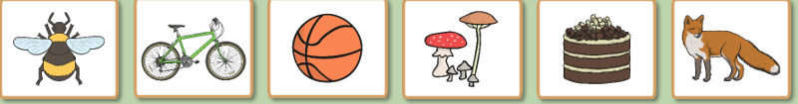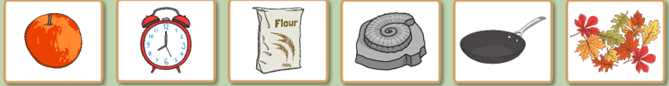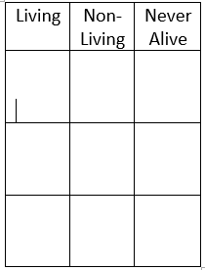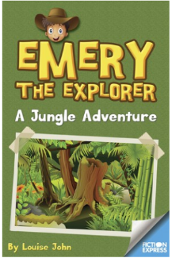

MATHS

For maths this week, we will revise our knowledge of fractions and start a new topic on length and height. Please follow this link to White Rose Maths Home Learning: <https://whiterosemaths.com/homelearning/year-2/>

There is a lesson for each week day which includes a short video and an activity sheet which are like the ones we often use in class. If you can’t print them out, then just write your answers on a separate piece of paper. There is an answer sheet too so you can check your answers.

Remember when finding a fraction of an amount look at the bottom number (the denominator) to find how many parts to break it into first and then use the top number (the numerator) to count how many of these parts you need to find.

**Please access Top Marks and TT Rock Stars to practise all of your other maths skills – I have set you a challenge for completing garage sessions.**

**\*\*You can now access NUMBOTS using your TT Rock Stars login. Have a go!**

READING

Visit the Fiction Express website and read the first chapter of Emery the Explorer – A Jungle Adventure. Complete the quiz. If there are any tricky words, ask an adult to explain them or look them up in a dictionary.

**My Year 2 Learning Journey Grid. Summer Term Wk1 20.4.2020**

ENGLISH

**For English this week, I would like you to complete activities based on Chapter 1 of Emery the Explorer – A Jungle Adventure.**

1. Emery packs his bag to go on an expedition. We know that he takes a toothbrush, a tent and a camping stove. What other things will he need? Write a list of all the things you would take with you if you were going to the jungle. Try to think of all the items you would need as well as the things you might like to take for fun. Remember, everything must fit into just one rucksack!

*2. Emery received a letter from the professor at the museum. The letter told Emery that there was some good news and some bad news. Read this section of the chapter again to find out exactly what the professor said, and then, in your own words, write the whole letter from the professor to Emery. Don’t forget to make up an address for the museum and a date for the letter. You could start with ‘Dear Emery’ and you could end with ‘Best wishes’ or ‘Good luck!’ or even ‘Bon Voyage!’ (which is French for ‘Have a good trip!’).*

3. In the story, Emery and Spider are going to look for the missing yellow diamond of the Amazon. Make up a short story telling the legend behind this treasure. You might like to think about the answers to these questions before you start writing: Why do you think the diamond is missing? What might have happened to it? Who did it belong to? How long has it been missing? What might it look like? How much money do you think it might be worth? When you have finished your writing, draw a picture of the diamond to go with it.

TOPIC: Create your own treasure map. Use your map to write some directions to help an explorer find the treasure. Look on a map to find out where the Amazon jungle is. How far is it from Bearpark? What else can you find out about the Amazon jungle? Create a factsheet about the Amazon. Draw a picture of Emery’s pet monkey – what kind of monkey do you think it is? The clue is in its name. What can you find out about spider monkeys? What other animals live in the Amazon? Draw a picture of your favourite.

*To help use the National Geographic Kids website and* <https://www.coolfactsforkids.com/spider-monkey-facts-for-kids/> **Any problems, please contact me and I’ll be happy to help. Have a good week. Mrs Jones ☺**

SPELLINGS

Practise these from Monday-Thursday and get someone to test you on them on Friday. Once you’ve gone through the correct spellings, write a super sentence for each one.

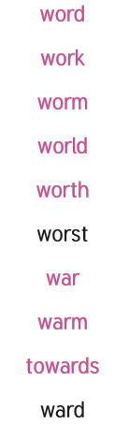

SCIENCE

Our topic this Term is ‘Living things and their Habitats’. This week I’d like you to visit <https://www.bbc.co.uk/bitesize/clips/zg7s39q> and watch the video ‘Is it alive?’ Once you have watched it, I’d like you to make a table and add each of the items to the correct column. Then add another item to each column that you can find in your home. Explain your choices to an adult.

Visit <https://durhamwt.com/nest-eggsplorers/> for lots of nature activities that you can explore and complete at home or in your garden.