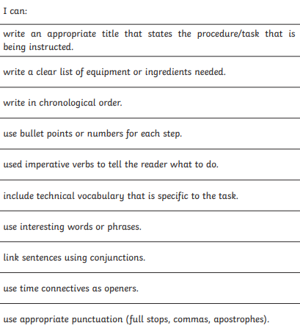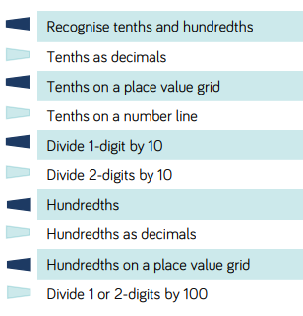

SPELLINGS

Practise these from Monday-Thursday and get someone to test you on them on Friday. Once you’ve gone through the correct spellings, give me an expanded noun phrase on each word:

**Fruit**

**Guide**

**Separate**

**Quarter**

**Occasion**

**Opposite**

**Experience**

**Famous**

**Favourite**

**Believe**

MATHS

For maths, we are continuing to follow our scheme and learn about decimals. This is a checklist of what we should know about decimals by the end of year 4:

As well as this, children should   
be able to:

* Recognise and write decimal equivalents   
  of any number of tenths or hundredths.

e.g. **1/10 is 0.1 and 1/100 is 0.01**

* Find the effect of dividing a one or two   
  digit number by 10 or 100, identifying  
  the value of the digits in the answer as   
  ones, tenths and hundredths.

e.g. 37 ÷ 10 = 3.7

37 ÷ 100 = 0.37

Discuss and make a place value table like   
we did in class and remember to move all  
numerals one place right when dividing by  
10 and two places right when dividing by 100.

**Roll two dice (or one twice). Write the number down and divide it by 10 and then 100. Once you’ve done this 10 times, order the original number and answers from smallest to largest.**

SCIENCE

Continuing our topic of ‘Electricity’, can you make a table with electrical components and the symbols used to represent them in circuits:

*Bulb/lamp, wires, voltmeter, motor, buzzer, switch (closed), switch (open), battery, cell.*

Once you’ve done this, draw me a complete, working circuit containing: a cell, wires, a bulb and a switch. *THEN* visit <http://www.sciencekids.co.nz/gamesactivities/electricitycircuits.html> which is a game that challenges you to create and change circuits to a given specification.

Visit:   
<https://whiterosemaths.com/resources/classroom-resources/problems/> to try their ***’Problem of the day’*** instead of our Arithmetic lessons!

ENGLISH

For English this week, I would like you to write a set of instructions on:

‘*How to make fairy cakes’*

We have covered instructions lots throughout the year – remember making our peg Borrowers back in Autumn term? Remember, for your instructions to be successful, you will need to:

Make it look as **exciting** and **colourful** as possible to encourage as many people to follow your recipe and make cakes…and email me your final piece!

**My Year 4 Learning Journey Grid. Week Beginning 20.4.2020**