

**My Year 3 Learning Journey Grid. Week Beginning 20.4.2020**

Visit:   
<https://whiterosemaths.com/resources/classroom-resources/problems/> to try their ***’Problem of the day’*** instead of our Arithmetic lessons!

MATHS

In maths, we are continuing to follow our scheme and learn about fractions. This is a checklist of what we should know about fractions by the end of year 3:

As well as this, children should be able to:

* Count up and down in tenths; recognise that tenths arise from

dividing an object into 10 equal parts and in dividing one-digit

numbers or quantities by 10.

* Recognise and use fractions as numbers: Unit fractions and non-unit

fractions with small denominators.

* Recognise, find and write fractions of a discrete set of objects: unit

fractions and non-unit fractions with small denominators.

If you have access to the internet log on to: <https://whiterosemaths.com/homelearning/year-3/> they have daily lessons which should take around 30-50 minutes to complete. There is a useful video which contains the teaching for each unit, and supports the activities for the unit which are alongside. There are answer sheets for the children to check their work or for parents/carers to check the answers. **This week start from Week 1 Lesson 1 to recap what we have done so far and, if you can, complete up to Week 1 Lesson 5.**

Ideas for activities not using the internet are listed on the following page.

ENGLISH

For English this week, I would like you to write a conversation between these two characters:

You could recap the rules for speech by watching; <https://www.youtube.com/watch?v=6-YFmLctwDY>

Here is a checklist to help with your writing:

**Challenge**: Can you add more detail into the conversation? Where are they, what are they doing? Where might they be going? What can they see or hear?

Maybe you could use some adverbs to your reporting clause to show how they are speaking. Can you change the placement of your reporting clause, put it at the start of your sentence or in the middle?

Can you use a variety of synonyms for ‘said’?

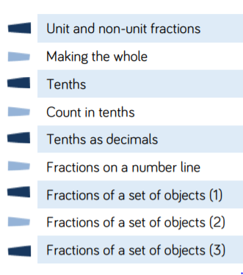

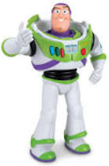

SPELLINGS

Practise these words from Monday-Thursday and ask someone to test you on them on Friday. Once you’ve gone through the correct spellings, write a sentence using each word correctly:

**Words ending in -ary.**

**library**

**February**

**dictionary**

**boundary**

**salary**

**summary**

**primary**

**secondary**

**ordinary**

**necessary**

Practise these words from your Y3/4 spelling list and include them on your test:

**purpose**

**possess**

**possession**

**particular**

**popular**

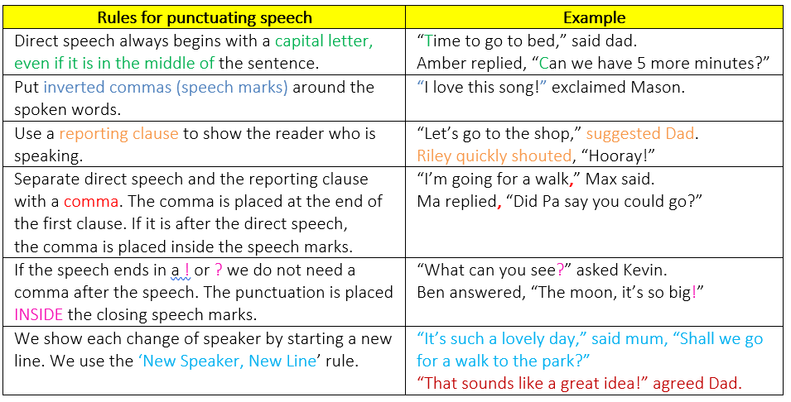

SCIENCE

Continuing our topic of ‘Rocks and soils’, use your knowledge organiser to create a glossary of the key vocabulary we have learnt. These should include: sedimentary, igneous and metamorphic, magma, permeable and impermeable.

What other vocabulary can you add to your glossary? Can you create your glossary using Word and add some pictures from the internet to make it more interesting? If you are hand writing your glossary, add some drawings and use colours to brighten it up.

Now watch this clip about soil and answer the questions given: <https://www.bbc.co.uk/bitesize/topics/z9bbkqt/articles/ztvbk2p>

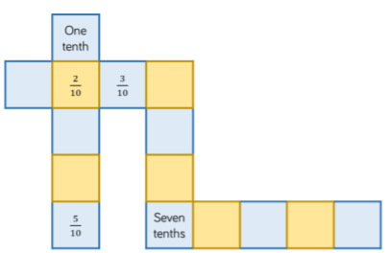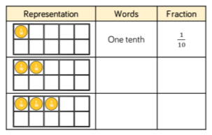

Don’t forget to email me a copy of any learning you do at home: [h.emma300@bearpark.durham.sch.ac.uk](mailto:h.emma300@bearpark.durham.sch.ac.uk)

READING SKILLS

Read the article: All about Tutankhamun’s tomb. Now use your reading skills to answer these questions:

1. Who gave Howard Carter the money to search for and excavate Tutankhamun’s tomb?

2. Which phrase is used to suggest that the discovery of the tomb’s entrance was a fortunate accident? Who discovered it?

3. Why did the Ancient Egyptians mummify their dead?

4. Name two things that were found inside the burial chamber.

5. How do you know that the Egyptians thought that the afterlife was very important? Give two reasons from the text.

6. Inside the tomb, Carter and his team found several chambers that were crammed with thousands of amazing artefacts dating back more than 3,000 years. What does the word ‘crammed’ mean in this sentence?

7. Look at the section The life of the boy king. Which word does the author use to suggest that the cause of King Tut’s death is not completely understood?

8. Look at the timeline of the discovery. Decide whether these statements are true or false:

a) It took two days to uncover the tomb entrance.

b) The chamber had been sealed for over 4,000 years.

c) Carter was the first to enter the chamber.

d) The sarcophagus of the boy King was decorated and covered in a precious metal.

9. Explain why the author does not fully believe that it was the curse that killed Howard Carter.

10. Why can’t we play Senet today?

MATHS

If you don’t have the internet then can you draw unit fractions and non-unit fractions with the same denominator?

Now try drawing some shapes and split them into equal parts. Colour your parts in different colours and label the fractions for each colour. Can you complete a bar model to represent your shapes?

Next draw a tens frame, if the frame represents 1 whole, what does each box represent? Can you use objects to represent one tenth, two tenths, one tenth less than eight tenths? How many other ways can you think of to challenge yourself or someone else in your house to represent tenths?

Following that activity can you now draw a counting stick, split into equal parts, label each part and practise counting forwards and backwards in tenths. When we get to $\frac{10}{10}$ what else can we say?

Now continue the pattern in my table:

Finally complete the sequences

in my puzzle:

Now draw a puzzle of your own

for someone else to solve.



What comes between $\frac{4}{10}$ and $\frac{6}{10}$?

If I start at $\frac{8}{10}$ and count back $\frac{4}{10}$ where will I stop?

What is one more than $\frac{10}{10}$?

Write at least 3 more questions and answer them.

