Bearpark Nursery Home Learning Tasks

Spring 2 2021 - Week 2 | Today’s task | Adult Input
Monday | Can you watch or read our story of the week?  ‘Three little pigs - Oxbridge Baby’ - YouTube | Ask your child What? Who? Where? How and Why? Questions.  Comment on what is happening and ask your child what they think might happen next.  After reading the story ask your child if they can read it back to you. They may be able to tell you the story using the pictures.  You can also draw the characters, cut them out and create a puppet show.
Tuesday | Can you make a puppet show?  Make the three little pigs and the big bad wolf to retell the story.  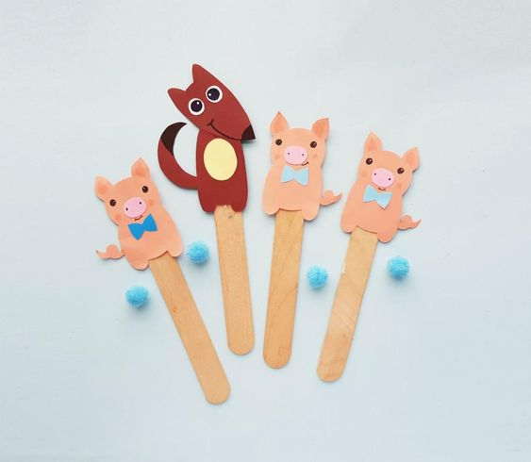 | Use anything in your house to make the three little pigs and the big bad wolf. Retell the story using the puppets. Encourage your child to recall and retell or for younger children to join in using the puppets.
Wednesday | Will the wind blow it?  Collect different items from your house or garden. Ask your child to blow it or use a hair dryer, then stick on some paper.  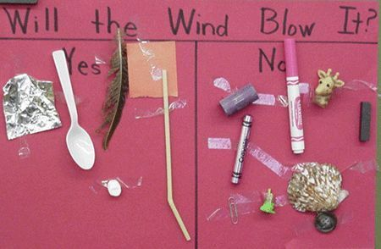 | Talk about the object being light or heavy. Discuss properties of the object and obvious differences. (big or small)  For older children ask how and why questions.
Thursday | Can you copy the dough disco moves? – YouTube | If you have no access to play dough, you can use a squashy ball or just some tissues.  You can find a recipe for homemade play dough on our website under ‘home learning Nursery’.
Friday | Can you make a house made of sticks?  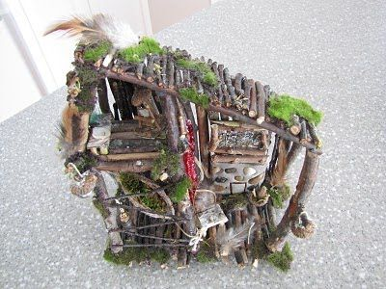 | Explore the great outdoors! Encourage your child to discover different textures, sounds, smells and the change in weather.  Go for a nature walk to collect some sticks. You can use glue to stick them together or stick them to a box using tape. Talk about what a house might need and what your house has. (Windows, roof, door etc.)  You can then use this with your puppet show for role play and story recall.
Challenge Yourself!! | Can you do 10 mins of dancing a day?  Koo Koo Kangaroo - YouTube | Ask the children to choose 2/3 dances from Koo Koo Kangaroo on YouTube.  We do this every day in Nursery to keep active!

Some helpful links for home learning:
https://www.bbc.co.uk/cbeebies
https://www.bbc.co.uk/cbeebies/watch/cbeebies-go-explore-app
- Excellent interactive activities online!
https://abcdoes.com/home-learning/
https://hungrylittleminds.campaign.gov.uk/
- Fabulous ideas for practical activities indoors and outdoors
https://resource-bank.scholastic.co.uk/content/40114?source=aw&awc=2957_1609948556_0bb65804906016aaccc8b1b61f2d75b4&fbclid=IwAR3jtWYz9cWjpq6cVCuTVQujnG8k5Wm47lWLZ3TQ-fYqKB5VfhkM5VIdTw0
- Free book resources!
I would also recommend looking on Pinterest for some inspiration!
Miss Clark would love to see what you have been doing at home! Please send your photos to v.clark301@bearpark.durham.sch.uk along with a caption.
These will then be placed in our floor book and spark discussion when we return!

