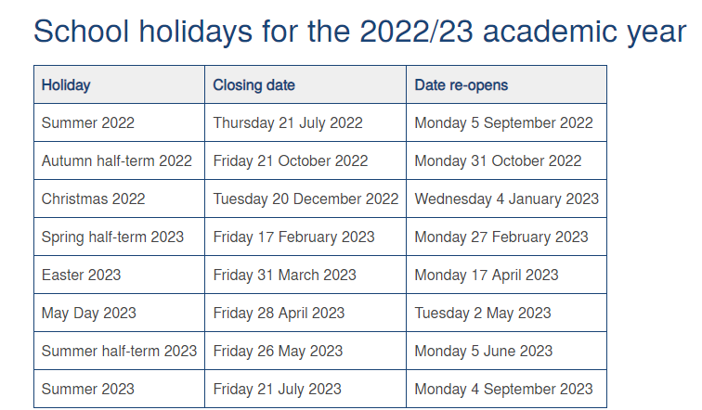

Teacher Training Days –
Monday 5th and Tuesday 6th September 2022
Wednesday 4th January 2023
Friday 26th May 2023
Monday 24th July 2023

