Design and Technology Knowledge Organiser | Year 1

Range of Tools |  | Main Processes |  | Food Technology Assessment of skills  By the end of the year children will be able to:
Scissors | 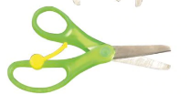 | 1.Investigate, observe and record  Discuss familiar products and recognise some of their features.  Discuss and evaluate what the product is used for.  Explore what they are made with.  Begin to form an opinion about the product. | 2. Generate Ideas  Think about and discuss what we see and use.  Decide who the product is for  What materials will we use  Think about how it will work  Sketch what you think it might look like | Understand all food comes from plants or animals (link to science) and that that food has to be caught, farmed, grown or fished.  Start to understand the 5 a day for fruit and vegetables (Link to science)  Be able to start to cut cucumber and tomato and grate some soft food.  Recognise a range of fruit, vegetables and ingredients such as cheese, flour, bread, butter/spread, milk, yoghurt, bananas, apples, peaches, lettuce, mushrooms, potatoes onion and tomato.
Glue | 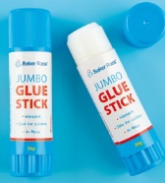
Fabric / Boxes | 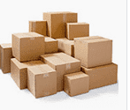 | 3. Design  Say what you are making  Create a template/mockup  Decide on your next steps  Think about the tools you might need | 4. Make  Select from a range of tools/materials  Follow rules for health, safety and hygiene  Start to measure, mark out and cut out materials  Assemble, join and combine parts of the end product | Technical Knowledge Assessment –  by the end of the year children will be able to :
Talk about the parts that make up the product

Discuss if the product moves –
mechanism, wheels, sliders
Talk about how product might become more stable/strong.
Use the correct vocabulary for example: button
Centimetre, fabric, needle, ribbon, sew
tape measure. thread, wool
Sellotape, glue Stick,paper clip, plasticine, ruler, straws,
2D, clay, cut, materials, metal, plastic and wood
Basic foods | 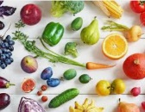 | 5. Evaluate  Discuss your own design  Decide if product is suitable and if it matches plan
Cardboard sliders | 