Design and Technology Knowledge Organiser | Year 2

Range of Tools |  | Main Processes |  | Food Technology Assessment of skills  By the end of the year children will be able to:
Eatwell Plate | 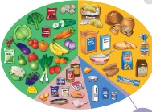 | 1.Investigate, observe and record  Discuss familiar ad unfamiliar products and recognise some of the design features.  Start to evaluate what the product is used for and who it is for.  Discuss what they are made from.  Give an opinion on existing products.  Start to record thoughts and findings by drawing and writing. | 2. Generate Ideas  Start to use drawings and annotations to record ideas.  Begin to use others ideas to create a better product | Start to understand the 5 a day for fruit and vegetables and link to an Eatwell Plate (Link to science)  Use a variety of skills:  Peel with a peeler. Spread (soft ingredients), mix, measure (with spoons) , shape, crush (soft fruit with potato masher) cut out with cutters, sift (flour into a bowl)  Understand different foods come from different climates and places around the world.
Potato Masher | 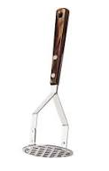
Sieve | 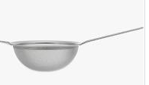 | 3. Design  Begin to suggest the next steps to make design better.  Start to use ICT where appropriate to generate a better product. | 4. Make  Start to develop an understanding of properies of materials.  Begin to join materials in a variety of ways.  Start to use materials independently.  Collect own materials and choose own ideas.  Use control to join materials  Start to explain choice of tools/ingredients or resources. Measure and mark out with some accuracy. | Technical Knowledge Assessment –  by the end of the year children will be able to :
Discuss movement mechanisms such as levers
Begin to understand ways of making 3D structures more stable n(strengthening triangles)
Start to discuss and investigate how to use learning from science and maths to help design products that work. (Measuring and forces)
Start to investigate the functional qualities of a product and how pleasant it looks.
Start to use more precise vocabulary
Centimetre, metre, fabric pens, needle , pattern, pin, ribbon, stitch, tape measure, velcro, zip
2D, 3D. metal, plastic, PVA glue, wire and wood
Foods from other cultures  (African fruit)  Mango, watermelon, papaya, star fruit, | 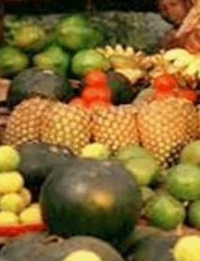 | 5. Evaluate  Begin to suggest product can be improved and pick out a positive in own product.  Record some evaluations using drawing and annotations.
Strengthening triangles | 