Design and Technology Knowledge Organiser | Year 3

Range of Tools |  | Main Processes |  | Food Technology Assessment of skills  By the end of the year children will be able to:
Kitchen scissors | 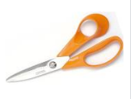 | 1.Investigate, observe and record  Evaluate what the product is used for and who it is for.  Explore the materials used.  Explain likes and dislaikes for existing products  Start to record thoughts and findings by drawing and writing. | 2. Generate Ideas  Use more drawings and annotations to record ideas.  Begin to use ideas from other people to create a better product | Sort food onto an Eatwell Plate (Link to science)  Use a variety of skills:  Mix with increasing thoroughness, grate cheese, spread (soft ingredients), measure (with spoons) , shape, crush (soft fruit with potato masher) cut out with cutters, sift (flour into a bowl) , thread (soft foods onto a cocktail stick  Understand different foods come from different climates and places around the world.
Peeler | 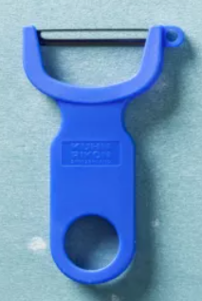
Cocktail sticks | 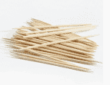
Maquette  Small mock up or model or sketch | 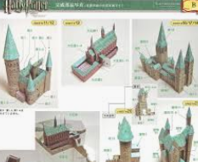 | 3. Design  Make some suggestions for the next steps to make design better.  Use some ICT where appropriate to generate a better product.  Create a maquette (small size model/mockup) | 4. Make  Develop an understanding of properies of materials and discuss preferences.  Join materials in a variety of ways.  Collect own materials and choose own ideas with confidence.  Use appropriate control to attach materials  Explain choice of tools/ingredients or resources. Measure and mark out with more accuracy. | Technical Knowledge Assessment of Skills  By the end of the year children will be able to:
Discuss movement mechanisms such as levers

Begin to understand ways of making 3D structures more stable (strengthening triangles)

Start to discuss and investigate how to use learning from science and maths to help design products that work. (Measuring and forces)

Start to investigate the functional qualities of a product and how pleasant it looks.

Start to use more precise vocabulary
Grams mililitres , ladle, hygiene
Cotton thread, loom, weave, running stitch fabric
Marking out, accurate, hacksaw, sandpaper, wheel
Analyse, combine, construct, evaluate
Axel |  | 5. Evaluate  Suggest how product can be improved and pick out a positive in own product.  Record evaluations using drawing and annotations.
Hacksaw | 