Design and Technology Knowledge Organiser | Year 4
Range of Tools |  | Main Processes |  | Food Technology Assessment of skills  By the end of the year children will be able to:
Vegetable parer | 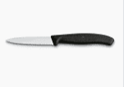 | 1.Investigate, observe and record  Start to evaluate how well existing products have been made  Explain why certain ingredients/materials have been included.  Show awareness of the materials used.  Explain how well product meets need/purpose  Discuss if product can be recycles/reused. | 4. Make  Follow safety/hygiene procedures  Select and use a wider range of material/components including mechanical/electrical components.  Measure and mark out with moire accuracy  Use appropriate control to attach materials  Use original design criteria to support make.  Apply a range of finishing techniques  Order the main stages of making  ____________________________  5. Evaluate  Start to identify strengths of own product and areas of development.  Consider the views of others to improve product  Refer to original design criteria in order to evaluate product | Practice the skills of how to prepare and cook a savouty dish safely and hygienically.  Discuss origins of food and show an understanding of where food comes from  Understand the idea of a healthy and balanced diet (Link to science)  Understand a healthy diet is needed to provide energy for a healthy body.  Explore skills such as cracking an egg and folding in flour  Measure (with a measuring jug), grate firmer foods like carrots  Arrange food in an attractive way  Thread medium resistant foods onto a skebab stick Cut foods progressing to using a vegetable parer.  Start to use a variety of safe food preparation skills
Measuring jug | 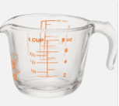
Electrical Circuit | 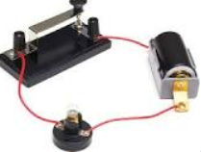
Cross section diagram | 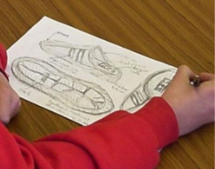 | 2. Generate Ideas  Share and clarify ideas through discussion  Begin to make changes based on availability of resources |  | Technical Knowledge Assessment –  by the end of the year children will be able to :
Begin to research and explore inventors and designs such as hovercrafts and James Dyson
Investigate the functional qualities of materials as well as what they look like.
Discuss and investigate how to use learning from science and maths to help design products that work. (Measuring and forces)
Investigate pneumatic systems and levers to create movement.
To understand how the components in an electrical system work and how they can be uised in products.
Start to use more precise vocabulary
Kilograms. grams mililitres,spatula, whisk, binca, cross stitch, pinking shears, thimble.
Vice, pliers, snips, battery, battery holder, light bulb
Gears, G clamp, pneumatics
Analyse, combine, construct, evaluate
Kebab skewer |  | 3. Design  Model ideas through simple prototypes  Start to use annotated diagrams and cross sectional diagrams to explain ideas.  Begin to CAD if appropriate or available  Generate realistic ideas focussing on needs of user
Pneumatic (air) system | 