Range of Tools |  | Main Processes |  | Food Technology Assessment of skills  By the end of the year children will be able to:
Grater | 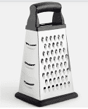 | 1.Investigate, observe and record  Record how well existing products have been made.  Explain why certain materials have been used  Understand what construction methods have been made and why. Explain how well product meets needs of user  Discuss if product can be recycled or recycled. | 2. Generate Ideas  Share and clarify ideas through clearer discussion  Make independent changes to ideas based on availability of resources.  Produce lists of equipment and resources needed. | Understand the origins of certain foods and where different food types comes from.  Understand the importance of a healthy diet for a healthy body.  Prepare and cook a savoury dish.  Peel with a peeler  Mix thoroughly  Measure accurately using scales  Grate firmer foods (carrots)  Thread medium and then firmer foods onto skewers (mushrooms - onions)  Cut firm ingredients using a range of grips for safety  Recognise and be aware of foods such as cous cous, some spices, taboulah
Peeler | 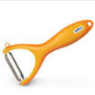
Press stud | 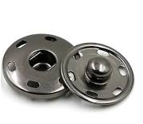 | 3. Design  Try out ideas through making prototypes  Use clearer anoottated sketches and cross sectional diagrams  Use CAD if available  Think of realistic ideas focussing on the needs of the user. | 4. Make  Follow all health and safety rules  Understand and use a wider range of materials including electrical and mechanical resources  Select and explain choice of tools and materials  Measure, mark out, cut and join materials accurately  Use original design criteria to support the make and start to change if appropriate.  Apply a range of finishing to make product appealing.  Order the main stages of making.
Cams and gears | 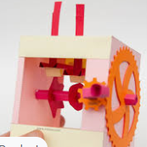 |  |  | Technical Knowledge Assessment of Skills  By the end of the year children will be able to:
Research inventors, designers and manufacturers who have developed ground breaking products such as hovercrafts, Levi Roots Sauces , Morse Code
Use learning from science and maths to help design products that work. (Measuring and forces)
IInvestigate how a product looks can influence its use. and aesthetic qualities of products
Investigate cams, pulleys and gears and how they can be used within a product
Recap on the use of pneumatic sysyems and pulleys .
Understand how the components in an electrical system work and how they can be used in products
Use precise technical vocabulary building on previous terms
Temperature, slow cooker, broil
Backstitch, press stud, seam allowance
Wire strippers, screws, nails, screw driver, dowel
Crocodile clip, file, pulley, bridge hold
Claw grip | 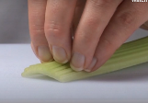 | 5. Evaluate  Identify strengths and areas for development for own product.  Consider the views of others to improve work.  Evaluate against original design plan.
Bridge hold | 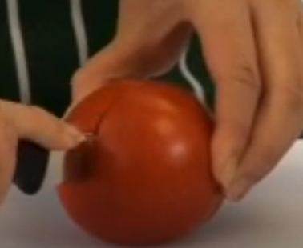
Design and Technology Knowledge Organiser | Year 5

