Design and Technology Knowledge Organiser | Year 6

Range of Tools |  | Main Processes |  | Food Technology Assessment of skills  By the end of the year children will be able to:
Slow cooker | 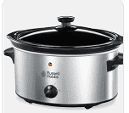 | 1.Investigate, observe and record  Discuss and explain  *how well existing products have been made  *why certain materials have been used  *what construction methods have been used  *how well product meets needs of user  *the sustainability of product  *the impract on the environment | 2. Generate Ideas  Share and clarify ideas through wider discussion  Use exploded diagrams to explore ideas  Use CAD if available  Generate realistic ideas for end user.  Make design decisions that take into consideration the environmental impact.  Carry out research using surveys and interviews.  Produce lists of equipment and resources needed. | Understand the seasonality of food available  To understand how food is processed into ingredients (wheat into flour)  Prepare and cook a savoury dish that may need a heat source .  Understand that a recipe can be adapted for appearance and taste.  Peel into ribbons (carrots/courgettes)  Measure accurately using scales  Grate using greater control (lemon for zest/nutmeg for flavour)  Thread firmer foods onto skewers (onions)  Cut firm ingredients using a range of grips for safety  To know there are a vast range of ingredients used around the world  Lemon grass, papaya , bean spouts, lentils, coconut, spices
Ribbon Peeler | 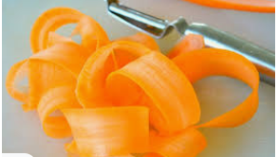
Cams and gears | 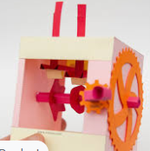 | 3. Design  Work confidently within a range of contexts  Explain how different parts of the product work  Identify the design features that appeal to wider audience  Develop design brief  Explain choices/practical features of materials | 4. Make  Select and explain choice of tools and materials  Create and follow step by step plans  Follow all health and safety rules  Use a wider range of components  Measure, mark out, cut and shape materials accurately  Use techniques that involve a number of steps  Demonstrate resourcefulness when confronted by problems  Show accuracy within all processes. | Technical Knowledge Assessment of Skills  By the end of the year children will be able to:
Exploded diagram | 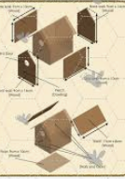 |  |  | Research inventors, designers, chefs and manufacturers who have developed ground breaking products.  Discuss and investigate how to use learning from science and maths to help design products that work. (Measuring and forces)  IInvestigate the functional and aesthetic qualities of products  Investigate cams, pulleys and gears and how they can be used within a product  To understand how the components in a complex electrical system work and how they can be used in products  Form a 3D textile product from a combination of fabric shapes  Use precise technical vocabulary.  Temperature, slow cooker, broil  Backstitch, press stud, seam allowance  Wire strippers, screws, nails, screw driver, dowel, Crocodile clip, file, pulley,
Press stud | 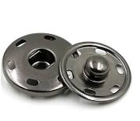 | 5. Evaluate  Identify strengths and areas for development  Consider the views of others including the end user to improve work.  Critically evaluate quality of design and the fitness of purpose.  Evaluate against original design plan.
Crocodile clip | 