Name | Scientist/Engineer | Images
George Washington Carver 1860s-1943 | Botantist, inventor and teacher.  He invented 300 uses of the peanut – invented methods to prevent soil depletion. Member of the British Royal Society of Arts – a rare honour for an American. | 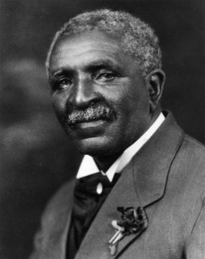
Mae Carol Jemison 1956… | Engineer, physician and NASA astronaut.  First African American woman to travel into space. | 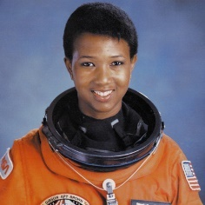
Katherine Johnson 1918-2020 | NASA Mathematician. | 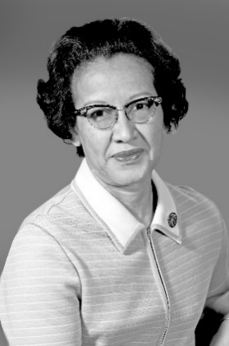
Rachel Carson 1907 - 1964 | Conservationist, biologist and author.  DDT – being banned. | 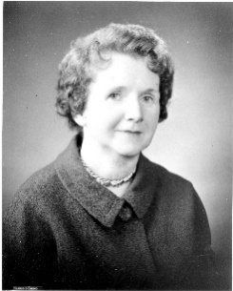
Marie Daly 1921-2003 | Chemist, researcher and analyst.  First African American woman to receive a PhD in chemistry in the US. How food and diets can affect the health of the heart and the circulatory system – with Quentin B Deming. | 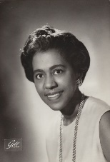
Edward Bouchet  1852-1918 | Physicist and educator.  First African-American to earn a PhD from any American university. Taught science for 26 years. | 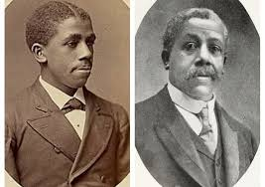
Annie Easley 1933-2011 | Computer scientist, mathematician and rocket scientist.  Worked at NASA as a ‘human computer’. | 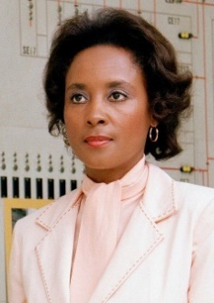
Walter Lincoln Hawkins 1911-1992 | Polymer chemist, scientist and inventor.  Inventing the plastic coating for telephone wires. | 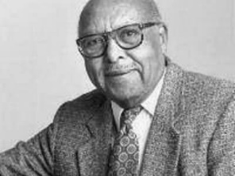
Alexa Canady 1950… | Surgeon, educator.  First African American neurosurgeon in the USA. Focusing on children. | 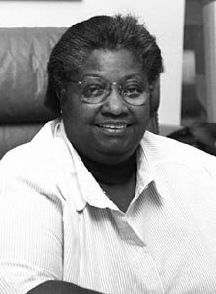
Isambard Kingdom Brunel 1806-1859 | Brunel built dockyards, the Great Western Railway (GWR), a series of steamships including the first propeller-driven transatlantic steamship, and numerous important bridges and tunnels. His designs revolutionised public transport and modern engineering. | 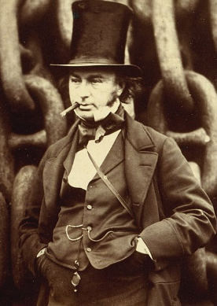
Margaret Calvert 1936… | Typographer and graphic designer.  Designed the fonts for our road signs. | 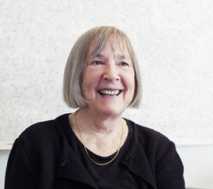
Dame Caroline Harriet Haslett, DBE, JP (17 August 1895 – 4 January 1957) | An English electrical engineer, electricity industry administrator and champion of women's rights. | 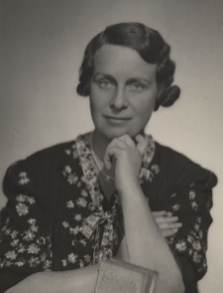
Beatric Schilling 1909-1990 | A British aeronautical engineer and amateur racing driver. During the Second World War, she designed and developed "Miss Shilling's orifice" to restrict fuel flow to the carburettor of the Rolls-Royce Merlin engines in the Hawker Hurricane and Supermarine Spitfire fighters. Previously the pilots had experienced a loss of power or even complete engine cut-out during combat manoeuvres, posing a potentially lethal disadvantage in the Battle of Britain.  Shilling raced motorbikes at Brooklands in the 1930s, one of only three women awarded a BMCRC (British Motorcycle Racing Club) Gold Star for lapping the circuit at over 100 miles per hour (160 km/h). After the war, she raced cars, mostly at Goodwood Members' Meetings. | 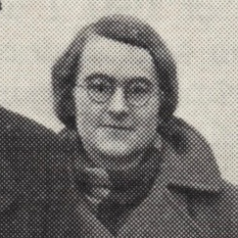
James Dyson | Sir James Dyson (born 2 May 1947) is a British inventor, industrial designer, landowner and entrepreneur who founded Dyson Ltd.  Traditionally, he is best known as the inventor of the Dual Cyclone bagless vacuum cleaner, which works on the principle of cyclonic separation.  According to the Sunday Times Rich List 2020, he was Britain's richest person with an estimated net worth of £16.2 billion.  He served as the Provost of the Royal College of Art from August 2011 to July 2017, and opened a new University, the Dyson Institute of Engineering and Technology, on Dyson's Wiltshire Campus in September 2017. | 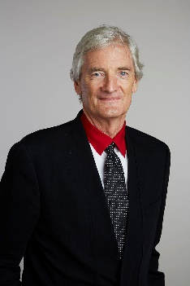
Henry Ford | Henry Ford (July 30, 1863 – April 7, 1947) was an American industrialist and business magnate, founder of the Ford Motor Company, and chief developer of the assembly line technique of mass production. By creating the first automobile that middle-class Americans could afford, he converted the automobile from an expensive curiosity into an accessible conveyance that profoundly impacted the landscape of the 20th century. | 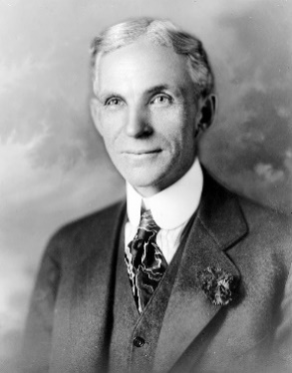
Alexander Graham Bell | Alexander Graham Bell (March 3, 1847 – August 2, 1922) was a Scottish-born inventor, scientist, and engineer who is credited with inventing and patenting the first practical telephone. He also co-founded the American Telephone and Telegraph Company (AT&T) in 1885. | 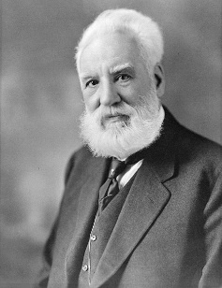
Lillian Moller Gilbreth 1878-1972 | Psychologist, engineer, and mother to twelve children.  Made huge improvements to the way we live with things such as shelves in fridge doors and pedal bins. | 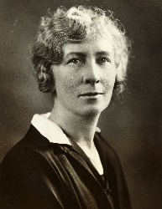
Hedy Lamarr 1914-2000 | She invented a way of transmitting secret radio messages in the Second World War. This technology is what is used for mobile phones and Wifi nowadays. | 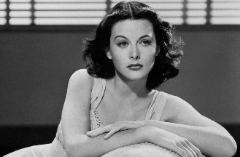
Martha Coston 1826-1904 | Best known for her device the ‘Coston Flare’ which are the pyrotechnic flares used for signalling at sea. | 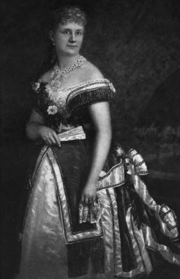
Ruchi Sanghivi 1982… | The first female computer engineer at Facebook.
Stephanie Kwolek  1923-2014 | She was a chemist who invented Kevlar, an incredibly light but very strong material used for many things including bulletproof vests. | 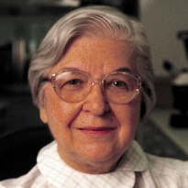
Marissa Mayer 1975… | In 1999, she was employee number twenty of Google and the company’s first female computer engineer. Now President and CEO of Yahoo. | 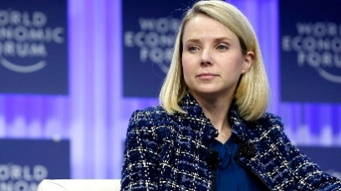
Marie Curie, 1834-1906 | Marie Skłodowska Curie. Polish and naturalized-French physicist and chemist who conducted pioneering research on radioactivity. | 