Year Group | Term
 | Autumn | Spring | Summer
EYFS  Nursery and Reception | Children will learn how to demonstrate friendly behaviour, initiating conversations and forming good relationships with peers and familiar adults. They will have a sense of own immediate family and relations. They will learn that they have similarities and differences that connect them to, and distinguish them from, others. They will be able to remember and discuss significant events in their own experience as well as describing special times or events for family or friends. They will enjoy joining in with family traditions and customs and learn about different traditions and customs from a range of cultures.  Special Times, Special Objects, Special Music, Special Books, Special People, Special Places and Belonging  Bearpark Nursery Goals:  Interact with others  Communicate wants and needs to others  Be kind and caring to others  Explore and Investigate the world- be a thinker and make links  Bearpark Reception Goals:  Listen carefully to others and express feelings  Be kind and show empathy towards others  Explore their world and show curiosity- be in awe of the world
EYFS  Cycle A  23/24 | Let’s find out about Harvest.  Let’s find out about Diwali.  Let’s find out about the Christmas Story.  Special People | Let’s hear some stories about Jesus- Zacchaeus.  Let’s find out about the Bible- The Easter Story.  Celebrations in different Cultures and World Views | Let’s find out about Christian baptism- visit the church  Stories and Special Places
EYFS  Cycle B  24/25 | Let’s find out about Harvest.  Let’s find out about Shabbat.  Let’s find out about Christmas celebrations in churches. | Let’s find out about the Torah, the Guru Granth Sahib and the Qur’an  Let’s hear some stories Jesus told- Lost Coin, Lost Sheep | Let’s find out about buildings and places of worship
Y1/2  Cycle A  23/24 | CHRISTIANITY  Why is the Bible special to Christians?  How and why is light important at Christmas? | CHRISTIANITY  What does it mean to belong to Christianity?  How do Christians celebrate Easter?  What can we learn from the story of St. Cuthbert? | MULTI FAITHS  What can we find out about our local faith/religious communities?  ISLAM: Who is God to Muslims?  How important is the Qu’ran  HUMANISM: What do Humanists believe?  SANATANA DHARMA: Who is God to Sanatanis?
Y1/2  Cycle B  24/25 | CHRISTIANITY  What can we learn about Christianity from visiting a church?  What do Christians believe about God?  Why are gifts given at Christmas? | CHRISTIANITY  Why is Jesus special to Christians?  What is the Easter story? | BUDDHISM  What can we find out about Buddha?  Why did Buddha leave home?  How do Buddhists worship and show their beliefs?
Y3/4  Cycle A  24/25 | CHRISTIANITY  So, What do we know about Christianity?  What is the most significant part of the nativity for Christians?  What do we know about the Bible and why is it special to Christians?  Why do Christians call Jesus the light of the world?  Has Christmas lost its true meaning? | JUDAISM  What is the Torah and why is it special to Jewish people?  How is Shavuot celebrated?  Why do Jewish people go to the synagogue? Jewish beliefs impact on life- leading a good life  Why is Lent such an important period for Christians? | CHRISTIANITY  How and why do people show care for others?  Why do people visit Durham Cathedral today? (Northern Saints)  Could Jesus heal people? Miracles  Do people need to go to church to show they are Christians?
Y3/4  Cycle B  23/24 | SANATANA DHARMA  What do Sanatanis believe?  How and why do Hindus celebrate Diwali? What might Sanatanis learn from Rama and Sita?  Does visiting the Ganges make a person a better Sanatani? | CHRISTIANITY  What can we learn about Christian worship, symbols and beliefs by visiting a church?  Is forgiveness possible?  What is ‘Good’ about Good Friday?  What do Christians remember on Palm Sunday?  Why are Good Friday and Easter Sunday the most important days for Christians? | MULTI FAITH  How do Sanatanis worship at home and mandir? How do they lead a good life?  Does praying at regular intervals help a Muslim in their everyday life?  Who is God to Sikhs?  What motivates Humanists to lead good lives?  Can Buddha’s teachings make the world a better place?
Y5/6  Cycle A  23/24 | MULTI FAITHS  What can we learn about religious diversity in our area?  What can we find out about a local Muslim Community?  How is the Qu’ran vital to Muslims?  How do they show commitment to God?  What are the themes of Christmas? | MULTI FAITHS  How and why do people care for the environment?  How do inspirational people impact on how Humanists live today?  Why is the last supper so important to Christians? | CHRISTIANITY  So, what do we now know about Christianity?  What is the best way for Christians to show commitment to God.  Is anything ever eternal?
Y5/6  Cycle B  24/25 | JUDAISM  Rosh Hashanah  Yom Kipper  Commitment to sacred teaching  Why is Moses important to Jewish people?  Why do Jewish people go to the Synagogue?  How are Jewish beliefs expressed in the home?  What do gospels tell us about the birth of Jesus? | CHRISTIANITY  What do Christians believe about God?  Is the Christmas story true?  Why are Good Friday and Easter Day the most important days for Christians? | MULTI FAITHS  Why do people use ritual in their lives?  Buddhist Commitment  How are Buddhist teachings interpreted by believers  How do people show care for others?

KS1- 36 hours across the year
KS2- 45 hours across the year
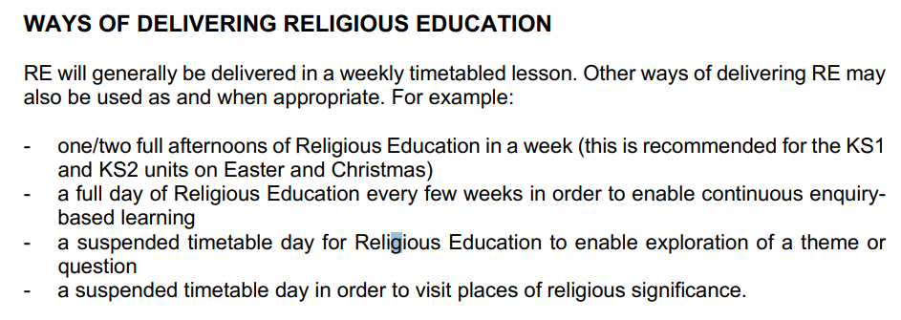

Knowledge and Understanding
Critical Thinking
Personal Reflection

OWLS
Reception- Bertie
Year 1- Abby
Year 2- Sophia
Year 3- Huey
Year 4 – Egbert
Year 5- Auberon
Year 6- Goodrun

