Homework will be given out every Friday and should be returned by Wednesday of the following week.

***Please ensure that your child brings their reading book into school every day.***

This Term, library books will usually be swapped on a Wednesday.

This Term, PE days will usually be Mondays and Wednesdays. PE Kits need to stay in school. No jewellery or tights on these days please.

**Supporting your child’s learning**

Reading with your child at home at least 3 times each week is essential. Play word games together. Practise any spellings sent home too.

Using RM Maths, TT Rock Stars, Fiction Express and Spelling Frame, as well as apps such as Hit the Button and One Minute Maths.

Chanting number bonds, comparing numbers, telling the time, practising times tables and asking division questions.

Year 1: Counting in 1s (forwards/backwards) 2s, 5s and 10s

Year 2: 2x, 3x, 5x and 10x



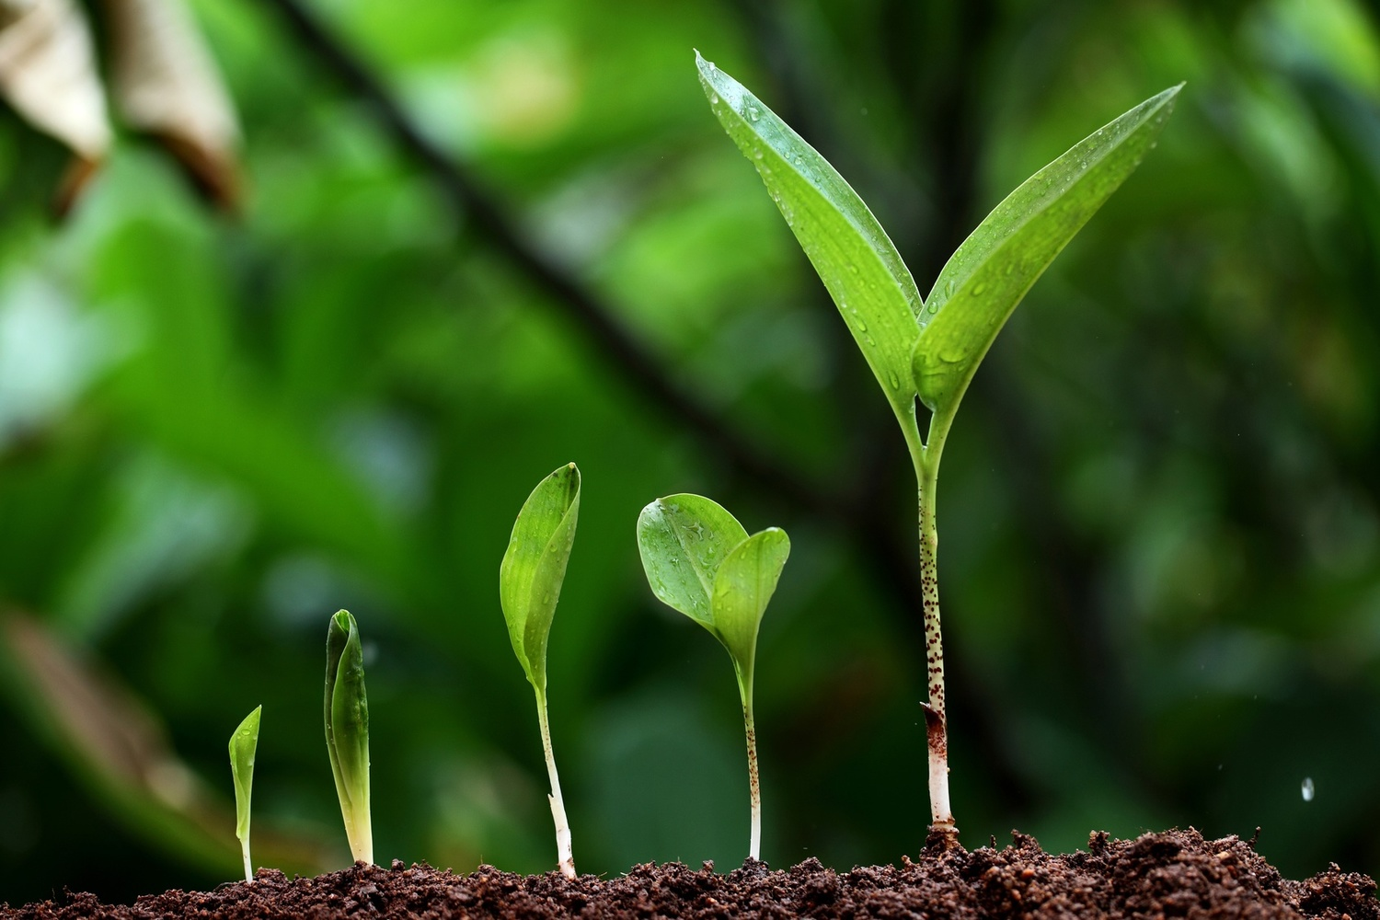

Class 2J Spring 2024

Bearpark Primary School

**Change**

I hope that your child feels settled at school.

If you have any questions or concerns, please do not hesitate to contact me. Mrs Jones.

d.jones201@bearpark.durham.sch.uk

RE

**Maths**

Regular Early Maths, Mastering Number and Times Tables practise

Year 1: Place Value to 50, and addition and subtraction within 20

Year 2: Multiplication and Division; Statistics

All: Fractions; Geometry: Properties of Shape; Measurement: length and height

**Science**

We will be continuing to explore everyday materials and their uses. We will compare suitability of everyday materials for a variety of purposes and how these materials can change.

We will learn about plants and growth, including being able to name the main parts of a plant, describe the different stages in a plant’s life cycle, recognise common plants and explain what a plant needs for healthy growth.

**English**

**Non-fiction texts** – A range of texts linked to our topics – The Great Fire of London and Plants. We will be looking at the diary of Samuel Pepys.

**Fiction Texts** – Samuel Squeaks’ Diary; a variety of alternative Fairy Tales, including Goldilocks and Just the One Bear, and Mr Wolf’s Pancakes; The Lonely Beast, and The Tear Thief.

We will be planning and writing for a range of purposes and developing our spelling and reading skills.

**RE**

We will be exploring these questions:

Why do Christians believe God gave Jesus to the world?

How important is it to Christians that Jesus came back to life after his crucifixion?

**PSHE**

The focus of learning will be relationships and living in the wider world.

**Art/D&T**

In D&T we will be developing our practical skills of cutting, shaping and finishing when designing and making bunting. We will use a range of tools and methods to join different fabrics and learn how to evaluate our design and work as we go.

In Art we will learn about contemporary artist Mike Barrett, and be developing our artistic skills – using a variety of techniques and media.

**Music**

In Music, our topic is ‘I wanna play in a band’ and we’ll learn about rhythm, beats and notes with Mr Preston.

**PE**

Through Dance, we will develop control, coordination, balance, poise and elevation in the basic actions of travelling, jumping, turning, gesture and stillness.

We will be exploring shape, balance and travel in Gymnastics and children will be making gymnastic sequences.

**Computing**

We will learn about programming through robot algorithms and develop our understanding of instructions in sequences and the use of logical reasoning to predict outcomes.

We will begin to understand what the term data means and how data can be collected in the form of a tally chart.

**History/Geography**

We will be learning about The Great Fire of London and why it was significant. We will be using a range of sources to find out about the fire. We will also find out about the Great Fire of Newcastle and Gateshead.

In Geography we will be extending our knowledge of the countries of the UK and the world’s continents and oceans. We will find out about hot and cold places. We will be developing our use of compass directions, mapping and recognising features and landmarks and using geographical vocabulary and language.

**Change**